**Analyze International Debt Statistics**

# ***Wireframe Documentation***

**Homepage:**

As per the problem statement, we have created a Dashboard which consist of all the KPI’s mentioned:

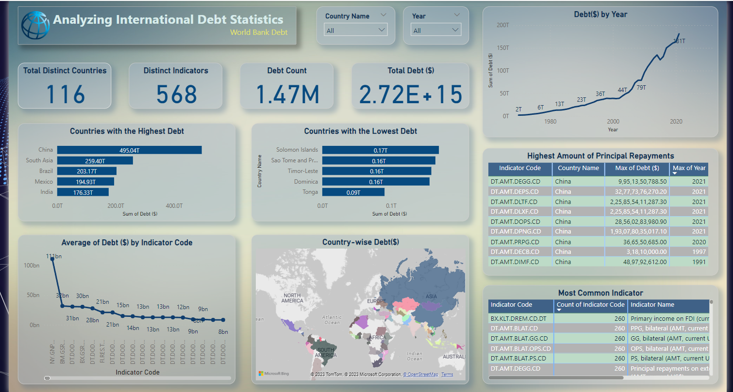

* Slicer for Country name and Year:



* Time Series Analysis of Debt in $ by Year:

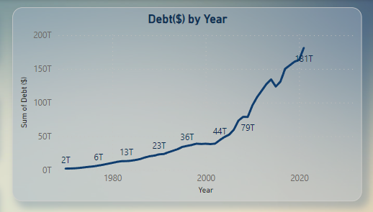

* Top 5 Countries with highest debt amount in $:

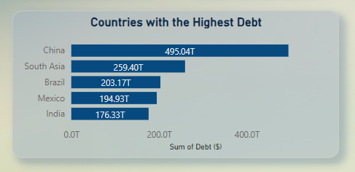

* Top 5 Countries with Lowest debt amount in $:

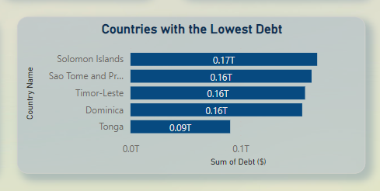

* Graph of Average debt per Indicator code by Indicator code:

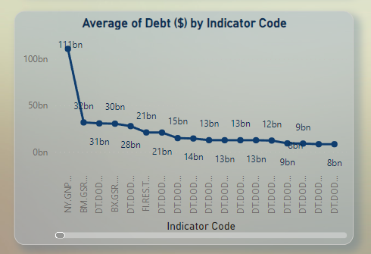

* List of Countries with highest amount of Principal Repayment and Year:

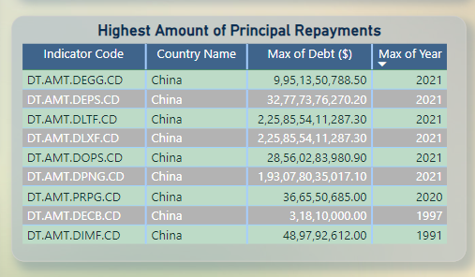

* List of most common indicator by count:

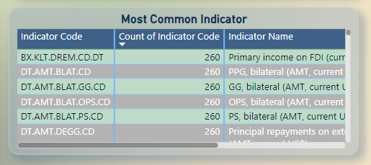

* Other KPI’s, Total Debt($), Total countries, Total Indicator’s, and Debt count:

